JIGSAW Thornbury Fun Palace Maker Registration Form
Saturday 2rd October 2021, 11-3pm
Name of group/ individual |  | Main contact (if different)
Phone number |  | Email
Would you like to run a short interactive workshop or have a space for the whole event?
Please include a description, including any information you will give out on the day, how many people can take part at one time, length of workshop and how many times you want to run it (if relevant).
Are you bringing any of your own equipment? Please list.
Do you want to hold the activity at JIGSAW or another location in Thornbury e.g. if you are holding it from a local shop
Are there any additional expenses or equipment you may require support with? Each request will be assessed individually.
Do you have any accessibility requirements?
Can you nominate another person or group to share their secret skill? Please get their consent beforehand. | Name:  Email:  Skill/ activity:
Disclaimer
Are you already a JIGSAW staff member or volunteer? Yes No
If not, are you happy to register as a one-off volunteer for the event? Yes No
If you are part of an organisation, do you have public liability insurance? Yes No N/A
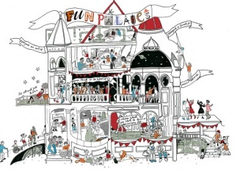
I the Exhibitor take full responsibility for staff, stock, equipment, belongings, and stall whilst in attendance at the event and accept to be the responsible person in the event that an incident occurs as a result the workshop or activity I am leading.
Signed: _____________________________ Date: ___________________

